Lila Product Engineer Written Test
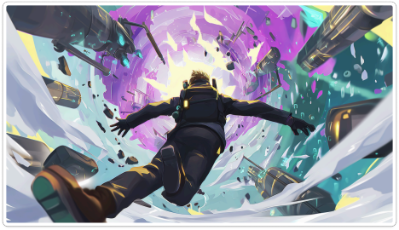At Lila, we believe the role of a Product Engineer is evolving beyond its traditional scope. The convergence of PC/console and mobile gaming, the emergence of AI, and other global trends are creating a new environment that will fundamentally reshape how we build and ship
exceptional gaming products.
We are looking for highly driven, intelligent, and creative problem-solvers who are passionate about delivering unique and compelling game experiences to players.
Our ambition isn’t just to compete in India; we aim to challenge the best studios in the world with products that are proudly “Made in India.”
We work on highly challenging and ambitious projects. If you are looking for a 9 to 5 job, this role is not right for you.
However, if you are ready for a massive challenge and willing to give it your all… << proceed forward >>
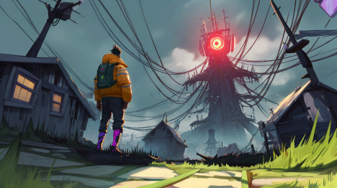—————————————————————————————————————————— —————
INSTRUCTIONS
1. We are looking for clear, concise, and well-thought-out responses
2. Use of AI to write any deliverables for this test is permitted
3. Deadline: 5 days from receiving this assignment.
4.Good luck!!!

Assignment: Player Journey Visualization Tool

Background
At LILA Games, our Level Design team needs a way to understand how players actually navigate our maps. Right now, they have raw telemetry data but no easy way to see what's happening visually — where players move, where fights break out, where people die to the storm, and which areas of the map get ignored.

Your job is to build a tool that turns this raw data into something a Level Designer can open in their browser and actually use.

What You're Getting
A zip file (player_data.zip) containing:

- 5 days of production gameplay data from LILA BLACK (an extraction shooter)
- Minimap images for each of the 3 maps in the game
- A README explaining the data format, schema, and coordinate system

Read the README carefully before starting. Everything you need to understand the data is in there.

The Task
Build and deploy a web-based visualization tool that lets a Level Designer explore player behavior on our maps.

Requirements
Core (must have):

- Load and parse the provided parquet data
- Display player journeys on the correct minimap, with world coordinates properly mapped to the minimap image
- Distinguish between human players and bots visually
- Show different event types (kills, deaths, loot, storm deaths) as distinct markers
- Allow filtering by map, date, and/or match
- Timeline/playback to watch a match unfold over time
- Heatmap overlays showing kill zones, death zones, or high-traffic areas
- The tool must be hosted and accessible via a shareable link

What We're NOT Prescribing
- Tech stack: Use whatever you're comfortable with — React, Streamlit, plain HTML/JS, anything. Pick what lets you move fast and deliver something polished.
- Design: No mockups provided. Figure out what the right UX is for this kind of tool. Think about who's using it (Level Designers, not data scientists) and design accordingly.
- Architecture: You decide how to structure the data pipeline, frontend, and hosting. There are many valid approaches.

Guidelines
- Use AI tools. We expect you to use Claude, Cursor, ChatGPT, Copilot, or whatever helps you move faster. This is not a test of whether you can write code from scratch — it's a test of whether you can use the right tools to ship something that works.
- Attention to detail matters. The data has nuances (coordinate mapping, bytes encoding, bot detection, timestamps). Getting these right is part of the test.
- Quality over quantity. A polished tool with 4 well-executed features beats a messy tool with 10 half-working ones.
- Document your assumptions. If something is unclear, make a reasonable assumption and note it. Don't get blocked.
- Timeline: 5 days. We expect this to take roughly 10-15 hours of focused work.

What We're Evaluating
Area | What we're looking for
System design | Did you make sensible architecture and tech stack decisions? Does the data pipeline make sense?
Attention to detail | Are coordinates mapped correctly? Are events rendered accurately? Did you handle edge cases in the data?
End-to-end execution | Does the tool actually work? Is it hosted? Can we open it and use it without your help?
Product thinking | Did you build something a Level Designer would actually find useful? Are the right things filterable/interactive?
Code quality | Is the code organized, readable, and reasonably structured?
Communication | Does your architecture doc clearly explain your decisions? Can you articulate trade-offs?

What to Submit
Send us a single github repo link with everything we need to evaluate should be inside that repo .

- Your code and a working deployment
  - The repo should contain all source code for your tool
  - Include a deployed URL where we can use it (Vercel, Netlify, Railway, whatever works)
  - A README that tells tech stack,setup steps, env vars, etc.
- An architecture doc (keep it to one page)
  - Put this in an ARCHITECTURE.md file. We want to see:
  - What you built with and why you picked it
  - How data flows from the parquet files to what shows up on screen
  - How you mapped game coordinates to the minimap — this is the tricky part, so walk us through your approach
  - Any assumptions you made where the data was ambiguous — just tell us what you ran into and how you handled it
  - Major tradeoffs — what did you consider and what did you decide? A simple table works fine here
- Three things you learned about the game using the tool you made
Create an INSIGHTS.md file. For each insight:
  - What caught your eye in the data
  - Back it up — point to a pattern, a stat, something concrete
  - Can you draw something actionable with this insight ? If yes , what metrics will get affected and what are the actionable items?
  - Why a level designer should care about it

Note : Only github repo links with all files will be accepted , doc links or drive links will not be accepted

Quick checklist before you submit

- Tool is live at the hosted URL
- Player paths render correctly on the minimap
- Can tell humans apart from bots visually
- Kill, death, loot, and storm events are marked
- Filtering by map/date/match works
- Timeline or playback shows match progression
- Heatmaps show kill zones, death zones, and traffic
- Architecture doc covers coordinate mapping approach
- Three insights with supporting evidence
- Walkthrough covers all major features

Good luck!!

